Week 3 & 4 Excercise
White House Logs
Tejashri Bhilare
MS in Data Science, Bellevue University
DSC640 – Data Presentation and Visualization
Professor - Catie Williams
December, 2024

White House Logs Summary

Audience
For this project, the audience is the general public, particularly individuals interested in government transparency and accountability.
This audience likely has minimal familiarity with the White House visitor logs, so the narrative and visuals must be accessible, clear, and engaging.
Technical jargon will be avoided to ensure the story resonates with a broad demographic, including those without prior data analysis experience.

Purpose
The purpose of this project is to promote awareness of patterns in White House visitor activities during 2021 and 2022.
The call to action encourages the audience to advocate for greater transparency in governmental operations and the publication of visitor data.
By shedding light on trends in visit purposes, high-frequency visitors, and meeting locations, this story aims to inspire public discourse and engagement with civic processes.
Medium
The data story will be presented as a visually engaging infographic, combining textual explanations with Python-generated visualizations.
This format ensures the information is easily digestible for the general public while maintaining an aesthetically pleasing design.
The infographic can be shared across social media, embedded in blogs, or distributed as a PDF for maximum reach.

Design Choices
The infographic's design will adhere to Gestalt’s principles to enhance readability and focus.
- Color: A harmonious palette will differentiate data categories, with contrasting colors used to highlight key findings and calls to action.
- Text: Minimal but impactful text will provide context for visuals without overwhelming the reader.
- Alignment: Consistent alignment will guide the viewer’s eye smoothly through the narrative.
- Sizing: Larger visuals and text will emphasize critical points, ensuring the audience’s attention is directed appropriately.
- Spacing: Ample whitespace will prevent overcrowding, making the infographic clean and professional.

Visuals
The infographic will include six visualizations:
- Bar Chart: Showcasing the number of visitors per month.
- Stacked Bar Chart with Time: Highlighting the purposes of visits over time.
- Scatterplot with Time: Mapping visitor arrival trends.
- Line Chart: Tracking changes in total visitors over the two years.
- Step Chart: Depicting cumulative visitor counts by month.
- Column Chart: Comparing the most frequently used meeting locations.

Ethical Considerations
- Data Transparency: Any transformations or filtering will be explicitly documented.
- Privacy: The data will be anonymized where necessary to avoid revealing sensitive personal information.
- Assumptions: Assumptions made during data cleaning (e.g., handling missing data) will be clearly stated.
- Accuracy: Only credible data from the provided datasets will be used, ensuring the story reflects the truth.
- Inclusivity: Visualizations and text will be designed to be accessible to individuals with visual impairments, incorporating colorblind-friendly palettes and alt-text descriptions for key visuals.

Call to Action
The intent of this story is to empower the general public to demand enhanced transparency in White House visitor records. By highlighting key patterns and trends, the story aims to:
- Raise Awareness: Help the audience understand who visits the White House, the purposes of these visits, and how this reflects governmental priorities.
- Promote Engagement: Inspire the public to engage with transparency initiatives by exploring and discussing publicly available data.
- Encourage Advocacy: Motivate individuals to advocate for more comprehensive and real-time data sharing practices from government institutions.
The desired outcome is for the audience to walk away informed and motivated to participate in civic processes by reaching out to policymakers, joining transparency-focused organizations, or staying informed about government activities.

This is the overall details about this White House Logs Summary story.
Now, let's dive deeply into visualizations.

We have used python tool to generate the visualization of this white house story.
As I mentioned earlier, we have used around 6 different types of visualization on this white house dataset.

Let's explore it now, here is the first one

Visualization - Visitors Per Month (Bar Chart)

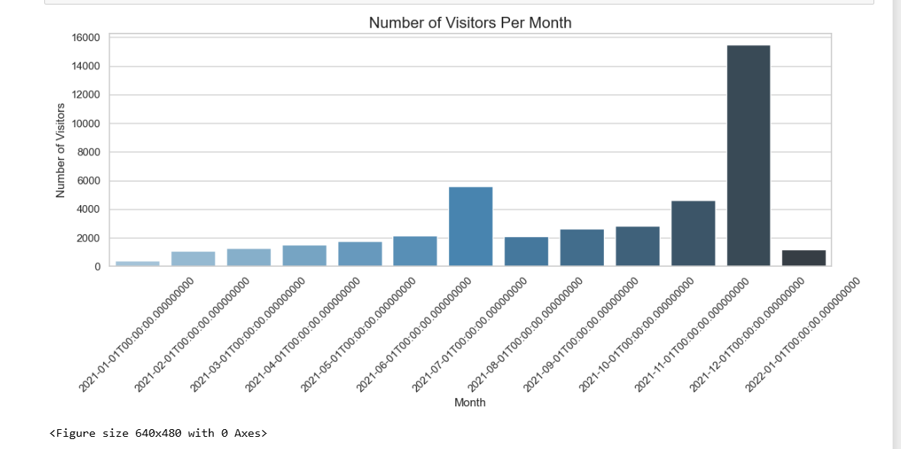

This above bar chart visualization represents total no of Visitors Per Month

2) Visualization - Total Visitors Over Time (Line Chart)

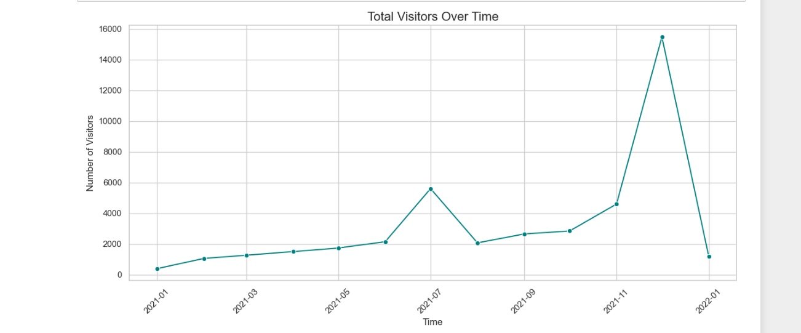

Here is the another type of line chart which signifies total visitors over given time period.

3) Visualization - Cumulative Visitors (Step Chart)

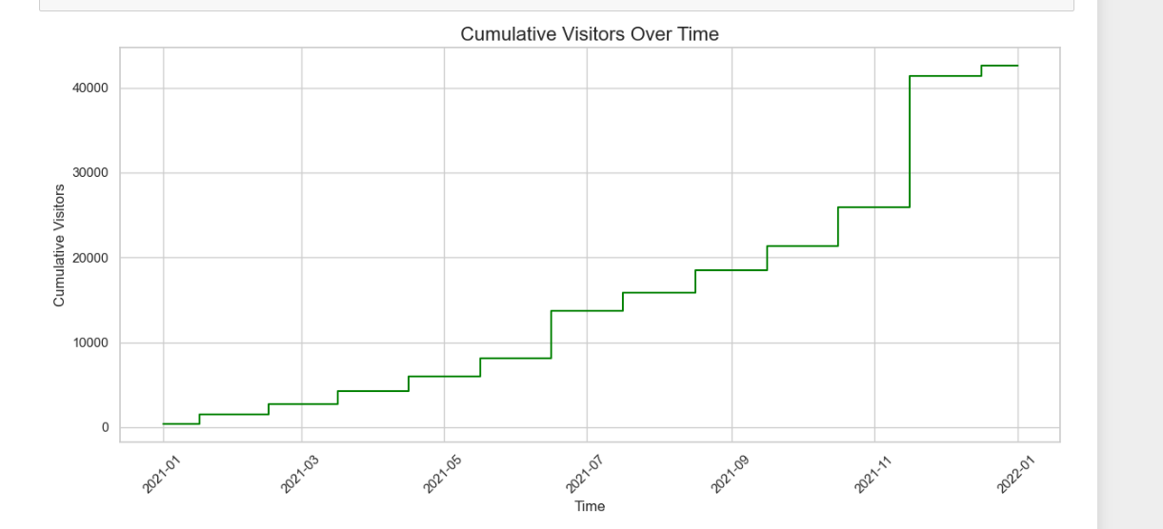

Here is another form of visualization, i.e., a Step chart , which shows cumulative visitors over time.

4)Column Chart: Comparing Most Frequently Used Meeting Locations

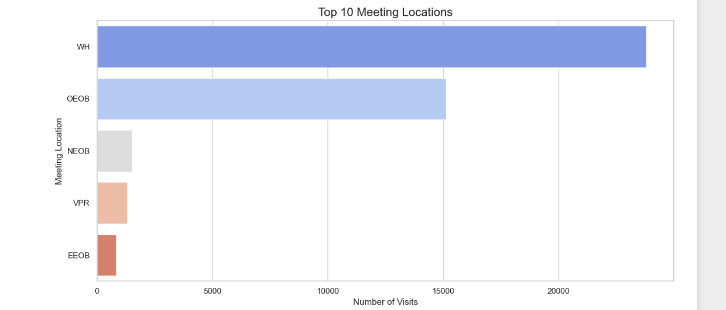

There are multiple meeting locations in the white house, and here in the above column chart , you can see the most frequently used meeting rooms.

5) Scatterplot with Time: Mapping arrival trends of top 10 visitors

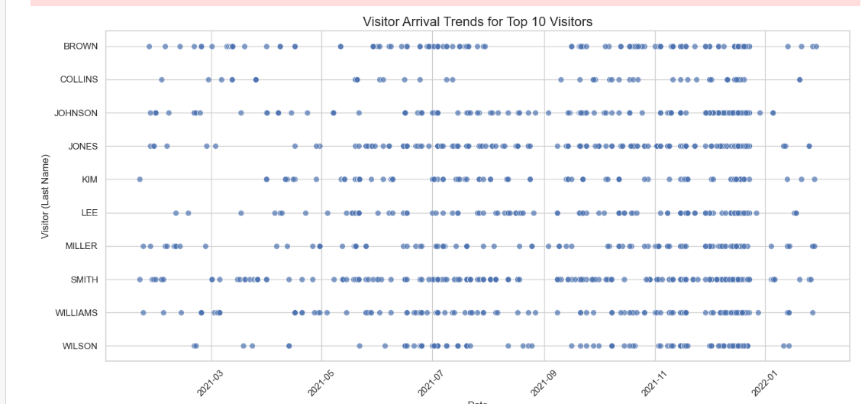
Multiple people are visiting Whitehouse everyday , however here is the scatterplot for the top 10 frequent visitors.

6) Stacked Bar Chart with Time (Top 10 Meeting Locations)

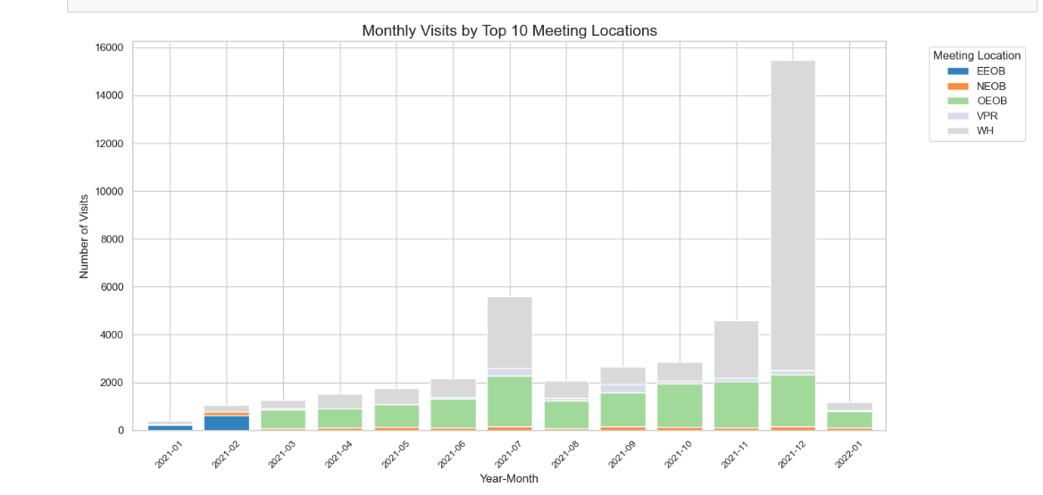

This last visual represents the stacked bar chart where you can see the monthly visits to the top 10 meeting locations of the Whitehouse.

